### **Halloween Spiders**

After creating the sliceform pumpkins, it dawned on me that the interior cuttings of the circle sliceform looked like a spider. However, the cuttings only had six legs and spiders have eight legs. No problem, using math, I created an eight-legged spider. Each of the legs is at a 45 degree angle. I found some random beads in my craft closet...one of the beads is from a broken necklace and the other beads are seed beads and glued them to the center of the spider.

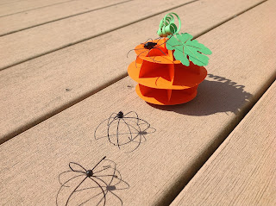

I love my spiders! They look so real that they fooled my cats. Be careful if you have a cat, they might want to steal it away and play with it.